**EX.No:** 3 **Name:** Nandhini A

**Date: 15/09/20 Reg.No:** 312217205054

**Creating And Pushing To GitHub Repository**

1. **GIT GUI:**

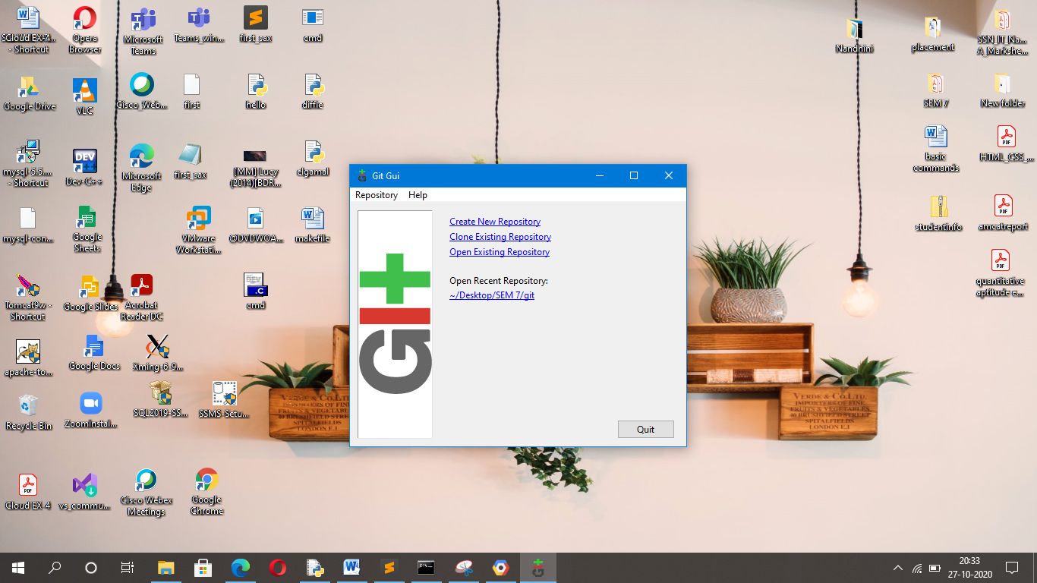

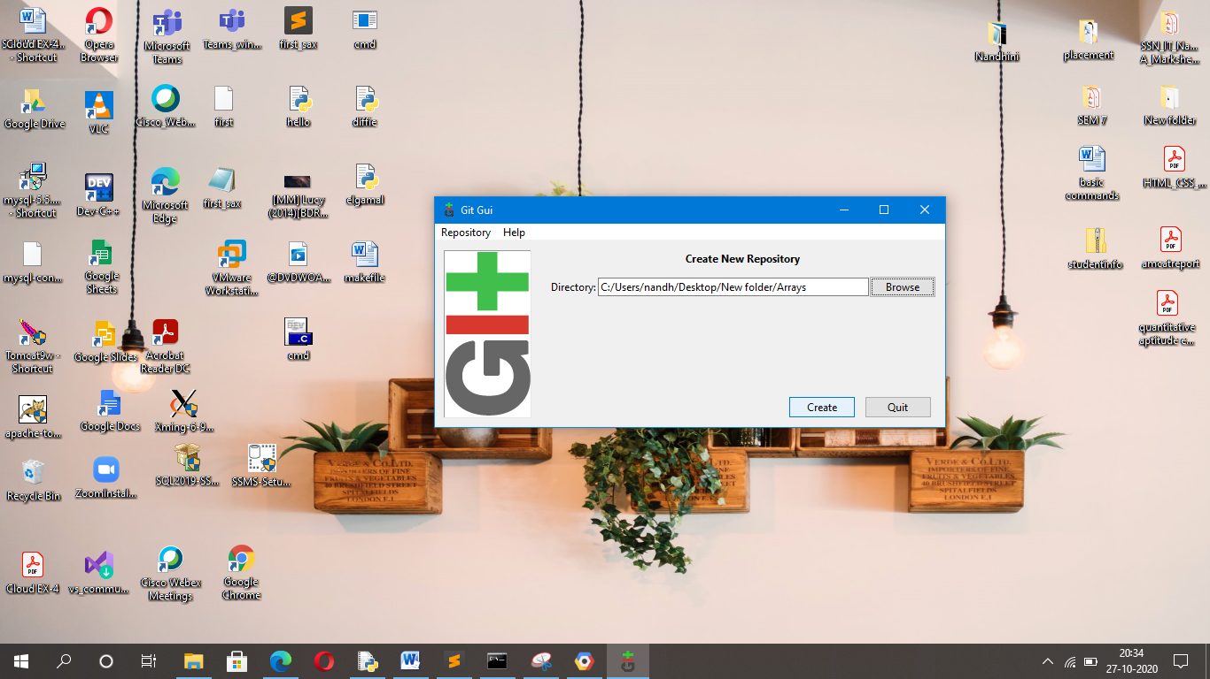

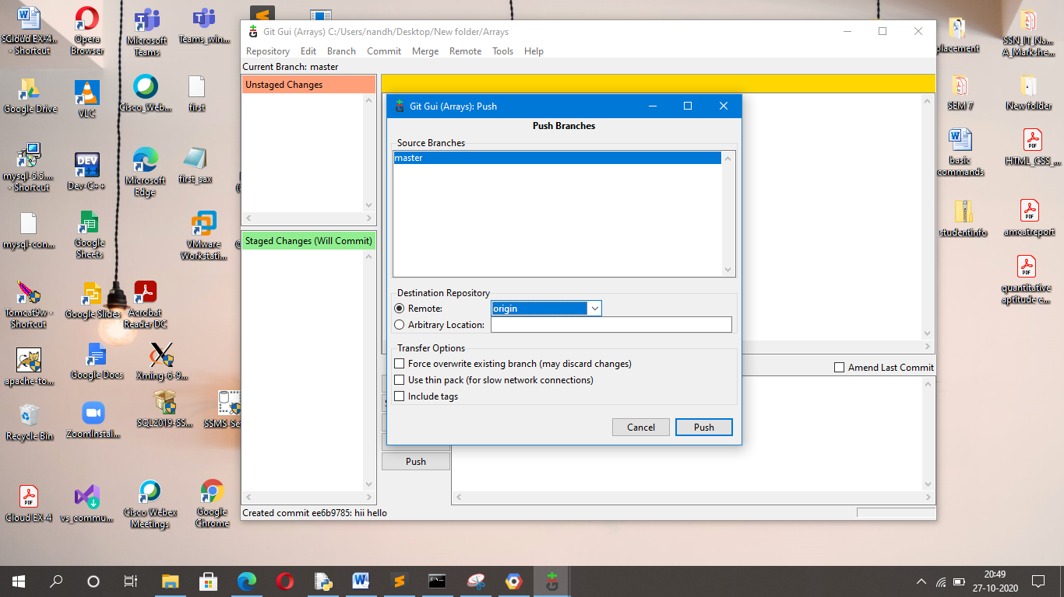

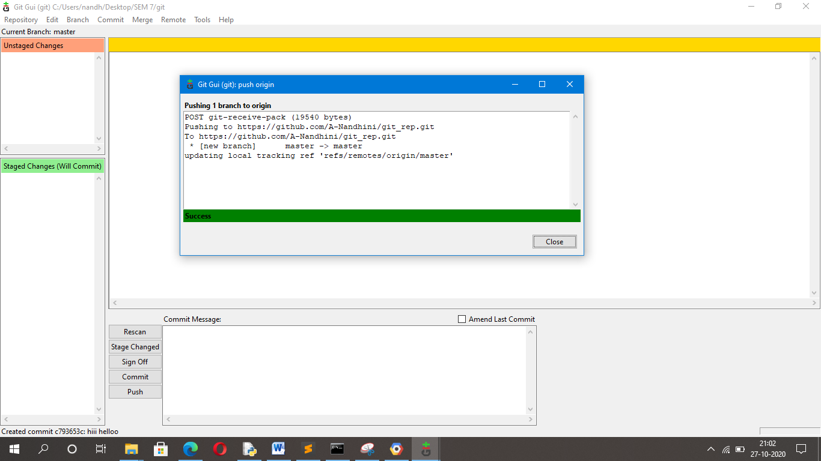

1. **GitHub Repository:**

